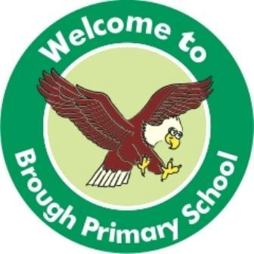
Brough Primary School
Springfield Avenue
Brough
E.Yorkshire
HU15 1AE
Telephone: (01482) 667352
Email: brough.primary@eastriding.gov.uk
Web: www.broughprimaryschool.co.uk

Headteacher: Mrs H Shepherdson
Tuesday 10th May 2022
Dear Parent/Carer
Phonics Screening Check 2022
Your child will retake the Phonics Screening Check in the week beginning Monday 6th June.
Please see the attached PowerPoint as a reminder of how the check will be administered in school and what the check entails.
You do not need to tell your child that this is coming up because it is nothing for them to worry about. The check will be carried out with their class teacher/s and is the same format as it was in the Autumn term.
Please get in touch with your child’s class teacher if you have any further questions.
Yours sincerely

Miss Fraser, Miss Stainton, Mrs Gay and Miss Mason

